ALL ARE WELCOME TO GET THE VACCINE
VACCINATION LOCATION HOUSING AUTHORITY OF FLORENCE

Moderna Vaccine
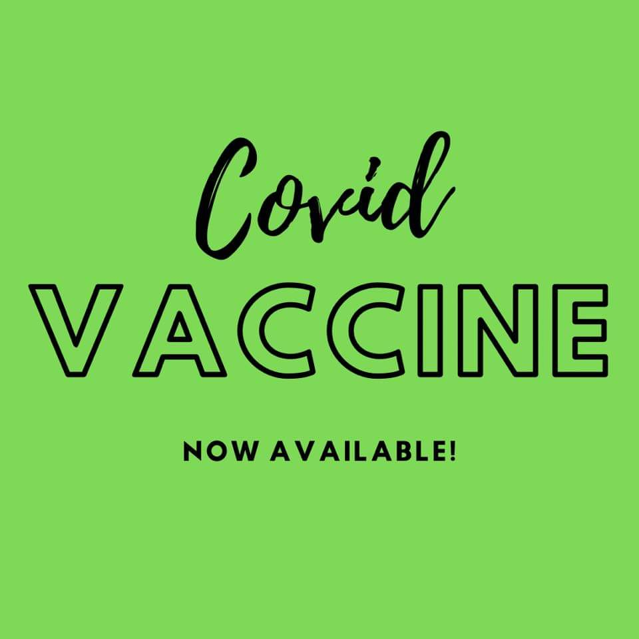
TUESDAY, DECEMBER 7, 2021
Lakota Crossing Apartments
1741 Lakota Drive
Florence, S.C. 29505

10:00 am - until - 2:00 pm
Booster Shots will be available

